Acts 21:7 When we had finished the voyage from Tyre, we arrived at Ptolemais, and after greeting the brethren, we stayed with them for a day.

Determined to get to Jerusalem by Pentecost, Paul and his companions did not delay in heading southward toward Judea. As they traveled they stopped for brief visits with the many believers along the way.

Acts 21:8-9 On the next day we left and came to Caesarea, and entering the house of Philip the evangelist, who was one of the seven, we stayed with him. 9 Now this man had four virgin daughters who were prophetesses.

In Caesarea, they stopped by the house of Philip who years before had first gone into Samaria to spark the fires of revival there. Philip now had a family including four daughters that prophesied!

Acts 21:10-11 As we were staying there for some days, a prophet named Agabus came down from Judea. 11 And coming to us, he took Paul's belt and bound his own feet and hands, and said, "This is what the Holy Spirit says: 'In this way the Jews at Jerusalem will bind the man who owns this belt and deliver him into the hands of the Gentiles.'"

While Paul was staying in the house of Philip, a prophet named Agabus came down from Judea and prophesied that the Jews would take Paul captive and deliver him a prisoner into the hands of the Gentiles!

Acts 21:12-14 When we had heard this, we as well as the local residents began begging him not to go up to Jerusalem. 13 Then Paul answered, "What are you doing, weeping and breaking my heart? For I am ready not only to be bound, but even to die at Jerusalem for the name of the Lord Jesus." 14 And since he would not be persuaded, we fell silent, remarking, " The will of the Lord be done!"

Hearing such dramatic news caused the fellow believers to beg Paul not to travel to Jerusalem, but Paul was determined to continue to Jerusalem because He had been instructed by the Holy Spirit to go there! Sometimes the perfect will of God is not always the easiest road to travel!

Upon arriving at Jerusalem, Paul and his entourage fellowshipped with the Apostles and then joined in with some Jewish believers that were gathering to worship in the temple.

Acts 21:27 When the seven days were almost over, the Jews from Asia, upon seeing him in the temple, began to stir up all the crowd and laid hands on him,

Having traveled to Jerusalem for the Feast of Pentecost, Paul’s Jewish enemies from Asia began to stir up the crowd against him. They dragged him out of the temple and began to beat him in a frenzied mob scene. When the Roman army received word that Jerusalem was in an uproar, the commander of the Roman cohort took soldiers and rescued Paul from the Jews.

Acts 21:33-34 Then the commander came up and took hold of him, and ordered him to be bound with two chains; and he began asking who he was and what he had done. 34 But among the crowd some were shouting one thing and some another, and when he could not find out the facts because of the uproar, he ordered him to be brought into the barracks.

The Roman commander took Paul into custody to save his life and as he was being escorted into the barracks, Paul shocked the commander by speaking to him in Greek! Realizing that Paul was not just an ordinary Jew, the commander allowed Paul to address the mob from the stairs of the barracks. Paul’s defense here was essentially a recap of his conversion experience. After Paul had spoken to the Jews and they had not received it, the commander discovered that Paul was a Roman citizen.

Acts 22:30 But on the next day, wishing to know for certain why he had been accused by the Jews, he released him and ordered the chief priests and all the Council to assemble, and brought Paul down and set him before them.

As Paul began to try to speak in his defense before the Jewish High Court, he realized that any argument was futile because of the determinedness of his enemies. Suddenly an idea came to the Apostle!

Acts 23:6-7 But perceiving that one group were Sadducees and the other Pharisees, Paul began crying out in the Council, " Brethren, I am a Pharisee, a son of Pharisees; I am on trial for the hope and resurrection of the dead!" 7 As he said this, there occurred a dissension between the Pharisees and Sadducees, and the assembly was divided.

Paul had been hated by the Jews because of his proclamation of Jesus’ resurrection. Knowing that one Jewish political party, the Pharisees, believed in life after death and the other party, the Sadducees, did not, Paul decided to stir up the enemy against each other.

Acts 23:9-10 And there occurred a great uproar; and some of the scribes of the Pharisaic party stood up and began to argue heatedly, saying, " We find nothing wrong with this man; suppose a spirit or an angel has spoken to him?" 10 And as a great dissension was developing, the commander was afraid Paul would be torn to pieces by them and ordered the troops to go down and take him away from them by force, and bring him into the barracks.

Paul had once been a fervent Pharisee and so he knew the right buttons to push to cause dissension in his enemies! The Pharisees and the Sadducees began to heatedly debate so much so that the commander finally rescued Paul away from them lest he be torn asunder!

Acts 23:11 But on the night immediately following, the Lord stood at his side and said, " Take courage; for as you have solemnly witnessed to My cause at Jerusalem, so you must witness at Rome also."

God reassured Paul that despite the tumult, he was in the perfect will of God! That night the nephew of Paul revealed to the Roman commander of a plot to kill Paul the next day in the Jewish council. Under the cover of night, the commander took several hundred soldiers and moved Paul to Caesarea for safety. The Roman commander also asked the Roman governor of the region, Felix, to hear the case against Paul.

Acts 24:1 After five days the high priest Ananias came down with some elders, with an attorney named Tertullus, and they brought charges to the governor against Paul.

After the Jewish lawyer made accusation after accusation, Felix allowed Paul to speak on his own behalf. After hearing both sides of the case, Felix responded to the charges against Paul:

Acts 24:22-23 But Felix, having a more exact knowledge about the Way, put them off, saying, "When Lysias the commander comes down, I will decide your case." 23 Then he gave orders to the centurion for him to be kept in custody and yet have some freedom, and not to prevent any of his friends from ministering to him.

Felix had already heard about Jesus Christ and His message and understood more of it than everybody realized! Not heeding the false accusations against Paul, Felix ordered that he be kept in custody until the Roman commander could come and testify but while he was held, Paul was allowed some freedom and full fellowship with the believers.

Acts 24:24-25 But some days later Felix arrived with Drusilla, his wife who was a Jewess, and sent for Paul and heard him speak about faith in Christ Jesus. 25 But as he was discussing righteousness, self-control and the judgment to come, Felix became frightened and said, "Go away for the present, and when I find time I will summon you."

Felix was married to a Jewish woman who knew the Hebrew scriptures. When she arrived in Caesarea, Felix summoned Paul to come speak to them about “faith in Christ Jesus.” As Paul preached concerning the kingdom of God, Felix became frightened and sent Paul away until he could “find time” again to hear him.

Acts 24:26-27 At the same time too, he was hoping that money would be given him by Paul; therefore he also used to send for him quite often and converse with him. 27 But after two years had passed, Felix was succeeded by Porcius Festus, and wishing to do the Jews a favor, Felix left Paul imprisoned.

Felix hoped that the Christians would give him a large sum of money for Paul’s release so he kept the Apostle bound. For two years, though, Felix would call for Paul quite often and converse with him and listen to his preaching. After two years, Felix was succeeded by a roman governor named Festus.
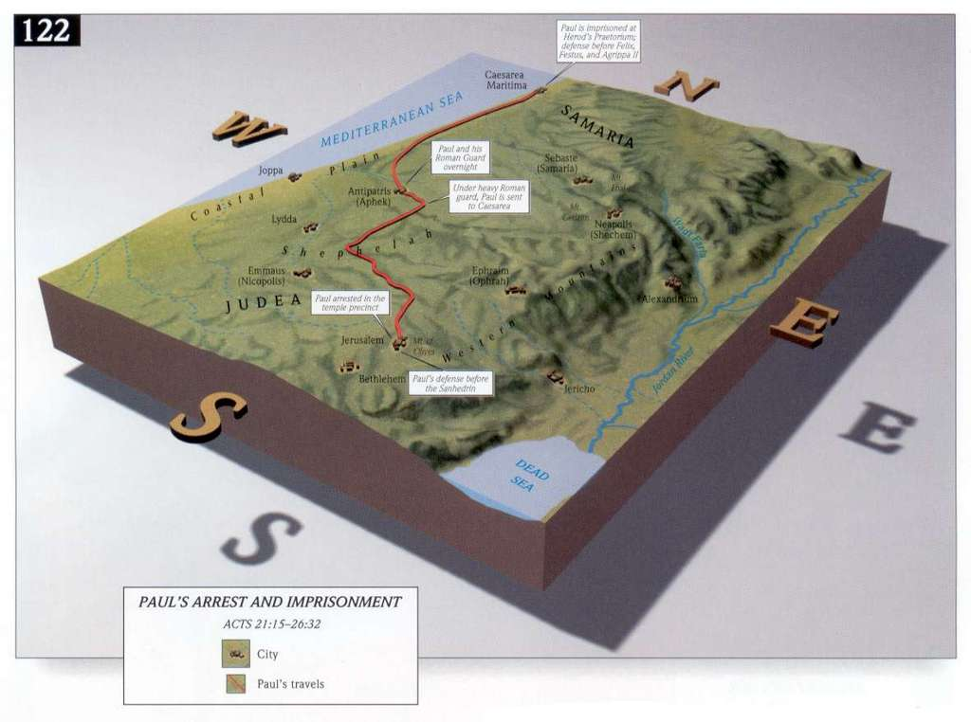
With a new governor in place, the Jews once again came to bring their false accusations against Paul. This time they asked Festus to allow Paul to stand trial in Jerusalem, all the while plotting to ambush him on the way and have him killed before he arrived in the city. Knowing what the Jews were scheming, Paul used his Roman citizenship to appeal to Caesar in order to keep from having to travel back to Jerusalem.

After some time, the son of Herod Agrippa, known as King Agrippa, arrived to visit Festus. During the visit Festus related the story of Paul and his imprisonment and appeal to Caesar and Agrippa desired to hear Paul in person.

Acts 25:23 So, on the next day when Agrippa came together with Bernice amid great pomp, and entered the auditorium accompanied by the commanders and the prominent men of the city, at the command of Festus, Paul was brought in.

Agrippa, along with Bernice his sister, gathered together in an auditorium with the Roman commanders and prominent men of the city and called for Paul. Paul knew that Agrippa believed in the Jewish God, and had great knowledge of the Hebrew scriptures and laws, so he took full advantage of the opportunity and preached with all of his might directly to Agrippa that Jesus was the Messiah. In the midst of this powerful sermons, Festus interrupted Paul:

Acts 26:24-25 While Paul was saying this in his defense, Festus said in a loud voice, "Paul, you are out of your mind! Your great learning is driving you mad." 25 But Paul said, "I am not out of my mind, most excellent Festus, but I utter words of sober truth.

Festus – not having a great knowledge of the Hebrew scriptures – did not fully grasp all that Paul was preaching. But Paul was preaching for the sake of Agrippa who fully understood everything that Paul was saying.

Acts 26:26-27 "For the king knows about these matters, and I speak to him also with confidence, since I am persuaded that none of these things escape his notice; for this has not been done in a corner. 27 "King Agrippa, do you believe the Prophets? I know that you do."

Paul used the interruption to let Agrippa know that he knew he was preaching to the king and that the king understood!

Acts 26:28-29 Agrippa replied to Paul, " In a short time you will persuade me to become a Christian." 29 And Paul said, " I would wish to God, that whether in a short or long time, not only you, but also all who hear me this day, might become such as I am, except for these chains."

Agrippa was being mightily moved by Paul’s preaching and Paul was testifying mightily before Gentile kings! And this magnificent sermon of truth was also being heard by the great Roman commanders and all of the important people of the city! After conferring with Festus and Bernice, Agrippa decreed that Paul had done nothing evil or wrong to the Jewish people.

Acts 26:32 And Agrippa said to Festus, "This man might have been set free if he had not appealed to Caesar."

Because Paul had appealed to Caesar, Festus and Agrippa could not release him but were bound to send him to Rome. Paul was grouped with some other prisoners and placed under the custody of a centurion of the Augustan cohort, named Julius. They “ship hopped” until they boarded a ship to Italy. After they were many days into the trip, Paul prophesied that if they continued the ship and cargo would be lost. Believing the captain of the ship more than a common prisoner, the centurion ordered that they continue sailing westward and find a place to spend the winter. It was after a few days of travel that the storm hit.

Acts 27:14-15 But before very long there rushed down from the land a violent wind, called Euraquilo; 15 and when the ship was caught in it and could not face the wind, we gave way to it and let ourselves be driven along.

“Euraquilo” in modern day language might be called a “northeaster.” A strong wind from the northeast began to send the ship across the Mediterranean Sea in a hurry. Seeing that Paul had predicted the storm, the centurion began to give more weight to the Apostle’s words. As the crew panicked and jettisoned the cargo overboard, Paul received a vision from God:

Acts 27:21-22 When they had gone a long time without food, then Paul stood up in their midst and said, " Men, you ought to have followed my advice and not to have set sail from Crete and incurred this damage and loss. 22 "Yet now I urge you to keep up your courage, for there will be no loss of life among you, but only of the ship.

Paul had heard from God that everybody would be safe!

Acts 27:23-24 "For this very night an angel of the God to whom I belong and whom I serve stood before me, 24 saying, 'Do not be afraid, Paul; you must stand before Caesar; and behold, God has granted you all those who are sailing with you.'

Not only would Paul one day stand before Caesar and testify of God’s grace, but the storm and trip would unfold in such a way that all of those aboard the ship would see and hear of the power of God!

Acts 27:25-26 "Therefore, keep up your courage, men, for I believe God that it will turn out exactly as I have been told. 26 "But we must run aground on a certain island."
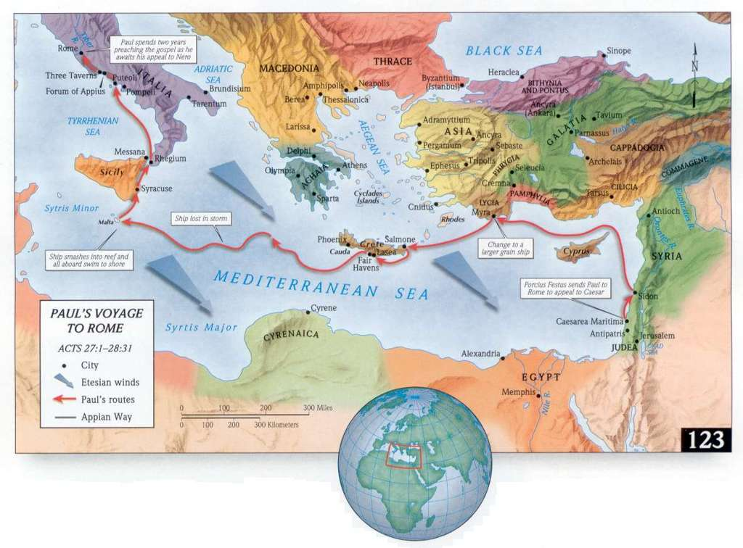
God was using the storm to propel the ship towards a certain island, the isle of Malta. After the ship broke apart, the crew and Romans and prisoners all drifted safely to shore and were greeted with friendliness by the natives of the island.

Acts 28:2-3 The natives showed us extraordinary kindness; for because of the rain that had set in and because of the cold, they kindled a fire and received us all. 3 But when Paul had gathered a bundle of sticks and laid them on the fire, a viper came out because of the heat and fastened itself on his hand.

When the natives saw Paul bitten by the deadly viper, they whispered among themselves that he must have been a murderer and had received his just reward. But Paul just shook off the viper into the fire and did not die! Amazed that he had survived, the natives began to treat Paul as if he were a god and a door opened up to hear about the one, true God, Jesus Christ.

The leader of the natives was a man named Publius and his father was deathly ill with fever and dysentery. When Paul prayed for him, he was healed and a mighty revival broke forth upon the island! The natives brought their sick to be prayed for by Paul and all of the members of the journey were eye witnesses to the power of Jesus Christ! The natives treated the shipwrecked crew with kindness for the entire winter and then outfitted them with another ship to make it to Italy. Three months after shipwreck, they finally arrived in Italy and made their way to Rome.

In Rome, Paul summoned the local Jewish leaders and presented his case to them. He was placed in a “house arrest” type arrangement where he could have unlimited visitors but could not leave his quarters. During this time, many of the Jewish leaders visited him and were won to God. The book of Acts closes in A.D. 62 with Paul in this arrangement and with these words:

Acts 28:30-31 And he stayed two full years in his own rented quarters and was welcoming all who came to him, 31 preaching the kingdom of God and teaching concerning the Lord Jesus Christ with all openness, unhindered.

During this two year time of imprisonment, Paul wrote four letters known as his “prison epistles.” We know these letters today as the books of Ephesians, Colossians, Philemon, and Philippians.

Sometime after A.D. 62, the Apostle Peter also came to Rome and from there wrote two letters to the church at large. The letters are known as the books of 1 Peter and 2 Peter in our New Testament. The book of 1 Peter was written because Peter could foresee greater persecution coming to the church and it's message is one of "stand for the truth no matter what may come your way." When Peter began to realize that the persecution would include his death, he wrote a final letter addressing and teaching on the major issues of the day; the book of 2 Peter is sort of Peter's last address and sermon to the church it warns against listening to the many false teachers that were already beginning to appear. Also at this time the book of Acts was being compiled and written by Luke from his many notes.

After A.D. 62, we only know bits and pieces of information from Paul's life. We do know that he was released from his prison confinement for a time. Tradition and history teach that, during this time, he visited Spain and a great revival erupted in that country. Eventually Paul returned to Macedonia where he wrote two more letters, the books of 1 Timothy and Titus. Timothy had become as a second son to Paul and was the current pastor of the church in Ephesus. The book of 1 Timothy was written from Paul as a mentor to a young pastor and contains much valuable advice for those who are in leadership of churches. The book of Titus was written to Titus who had been directed to establish churches and place pastors over them in the island of Crete. It also contains sound advice for spiritual leadership and choosing Godly leaders.

In A.D. 64, major persecution upon the Christian church began from the Roman emperor, Nero. The city of Rome suffered a major fire in a working class section and it burned out of control for seven days, destroying ten of the fourteen wards of the common people and killing thousands. After the fire, Nero seized much of the land and built himself the famous "Golden Palace" upon it; using public money to do so. Many of the people of Rome felt like Nero had set the fire himself and when the complaining began to swell into an uproar, Nero got out of his predicament by blaming the Christians. They had set the fire – he claimed – and he vowed to hunt down everyone of them and cruelly kill them to make amends. At this time, many Christians were burned at the stake or fed to lions. Some were set fire as human torches to light up Nero's gardens during his parties. Still others were beheaded in front of their children and families. This period of extreme persecution lasted until Nero's death in A.D. 68. Peter's prophecy of persecution had come true, yet instead of Christianity ceasing, it began to grow with even more fervor!

During this tremendous persecution of Nero, Peter was arrested in Rome and was sentenced to death. Tradition says that when he realized that they intended to crucify him, he screamed that he was not worthy to die like Jesus Christ and was crucified upside down. Peter was killed in A.D. 65. At about the same time, Jude, one of Jesus' brothers who along with James had become a leader of the Early Church, wrote a letter to the church at large. In it, he joined with Peter's earlier letters in warning of the many false teachers which were beginning to appear during the time of persecution. His letter is known as the book of Jude in our modern New Testament.

After Peter was killed, Paul was also arrested in Rome and again placed in prison. During this time, he wrote his final letter, the book of II Timothy. It gave more practical, pastoral advice to the young minister and also served as Paul's last address to the church. When he wrote the letter, Paul knew that the time of his death was near:

2 Tim 4:6-8 For I am already being poured out as a drink offering, and the time of my departure has come. 7 I have fought the good fight, I have finished the course, I have kept the faith; 8 in the future there is laid up for me the crown of righteousness, which the Lord, the righteous Judge, will award to me on that day; and not only to me, but also to all who have loved His appearing.

Paul was beheaded by Nero in A.D. 68. Tradition says that he cheerfully laid his head down upon the chopping block and gave up his life without a fight. During this persecution of Nero, the other disciples and church leaders had spread throughout the world teaching and preaching the Gospel of Jesus Christ; once again God used persecution to spread His glorious truth. Every one of the original early apostolic leadership except the apostle John died a martyr; all of them were killed for preaching the Gospel of Christ. At this time, the leadership role of the early apostolic church fell into the able hands of Timothy, Titus, John Mark, and the older John.

In the late A.D. 60s, the Jewish leaders of Jerusalem started a revolt against the Roman rule in Judea. Roman armies were sent to fight the rebels, and the revolt dragged on for a few years because of the confusion that resulted from Nero's death, but eventually, in A.D. 70, the Roman general Titus marched into Jerusalem and leveled and burned the city. At this time, he also completely destroyed the temple there thus fulfilling the prophecy of Jesus that one stone would not be left upon another. Because of this, the sacrifices of the law of Moses came to an abrupt halt and the Jews scattered throughout the world to avoid the punishment of the Romans. Israel would not come together as a nation again until A.D. 1948. Furthermore, to this day, there is not a Jewish temple in Jerusalem.
We only know bits and pieces about the remainder of the apostle John's life from scripture, history, and church tradition. Tradition says that he was sentenced to die by boiling in oil in Rome but survived. Whether or not those stories are true, It is certain that John did move to Ephesus and as an older man was arrested and banished to the island of Patmos. While in Ephesus, John wrote three letters, the New Testament books of 1 John, 2 John, and 3 John. The book of 1 John was written to teach mature believers on how to love one another and to fellowship in a Godly way. The book of 2 John was a warning against false teachers and doctrines. The book of 3 John was a personal letter to commend the faithfulness and works of two men named Gaius and Diotrephes.

While exiled on isle of Patmos, John saw visions of future events and wrote them down as the book of Revelation. The first three chapters of the book of Revelation were direct messages of God to seven churches in Asia, the churches in Ephesus, Smyrna, Pergamos, Thyatria, Sardis, Philadelphia, and Laodicea. The remainder of the book deals with prophecy of past and future events.

Throughout the last years of his life, John was also writing a book detailing the first and third year of Jesus Christ's ministry. These written memories became the Gospel of John and was written to elaborate and "fill-in-the-blanks" of the other gospels. Most people do not realize that John did not die on the island of Patmos but eventually returned to Ephesus for the last few years of his life. Church history records that he called everyone “beloved,” was extremely supportive of the younger church leadership, and that he died of natural causes in Ephesus sometime shortly after A.D. 100. John died full of years and faithful to Jesus Christ and his death signaled the close of the early apostolic era.

Notice the “we” of these passages indicating that Luke is still with Paul and his company.
See the 8th chapter of Acts.
This is the same Agabus that had correctly prophesied about the coming famine in Acts 11:28.
Because we have already studied Paul’s conversion in detail, we will not study his oration verse by verse. It can be found in the 22nd chapter of Acts.
Paul’s first defense before Felix is found in the 24th chapter of Acts.
What was really happening was that Felix was getting a revelation of the truth of Jesus Christ and with that revelation came the realization that he must change his lifestyle to obey the scriptures. Unfortunately, Felix put off such obedience until “later.”
Although she was his sister, history records that Agrippa and Bernice were living together incestuously.
Paul’s sermon is found in the 26th chapter of Acts.
Notice that the “we” of these passages indicates that Luke was with Paul for the duration of this eventful journey.
The books of 1 Timothy, Titus, and the later written 2 Timothy are sometimes referred to by scholars as the "pastoral epistles."
See Matthew 24:1-2.
Some scholars give a date for John’s death as late as A.D. 110.
Endnotes ? The original prophecy given by Ananias at Paul’s conversion was that he would be a light “before the Gentiles and kings” (Acts 9:15). All of these trials are serving to give Paul an audience with rulers and governors of the Roman empire. Even kings deserve an opportunity to hear the truth of the Gospel of Jesus Christ and through Paul, they were able to hear about Jesus Christ!
If a Roman citizen thought that his case was being tried unfairly, he had the right to “appeal to Caesar” and eventually travel to Rome and have his case tried by Caesar, himself. Paul’s appeal had two purposes: it delivered him out of the hand of the Jews who were plotting to kill him on the road to Jerusalem, and it ensured his desired trip to Rome would take place. Only now he would go to Rome at the expense of the Roman Government!
Those who are familiar with the King James Version will notice the lack of “almost thou persuadest me to be a Christian.” The translation of the NASU is actually more accurate to the Greek than the KJV’s rendering. The idea expressed is that Agrippa thought that it would take a long time and much convincing to become a Christian. And that such a conversion was not possible instantly! To become a Jew, one had to learn many laws and go through many rites such as circumcision and the Day of Atonement. But Christianity could be attended to in a moment of faith and obedience. Agrippa’s problem with Paul’s preaching was that the king had convinced himself that it could not happen so quickly or easily. Oh, the men and women today that believe the same lie! Let us remember that God can restore in a moment of faith and obedience what it took sin a lifetime to destroy!
The book of Ephesians is a terrific theological work meant to strengthen and encourage the church in Ephesus. It is one of Paul's greatest masterpieces about the church and the Christian walk. The book of Colossians is simply a condensed version of Ephesians and was meant to strengthen the doctrine of Christ in the church at Colosse. The small book of Philemon was a letter written to a man in the church in Colosse and sent along with the book of Colossians. It was written on the behalf of one of Philemon's runaway slaves, a man named Onesimus, whom Paul had converted in Rome. In it Paul was asking basically two things: that Philemon would receive, forgive, and love Onesimus as a Christian brother, and that he would permit Onesimus to go free for the work of God. Obviously Philemon did both as fifty years later, Onesimus was referred to as the "bishop" or pastor of the church in Ephesus by Ignatius, the pastor of Antioch! The small book teaches very important lessons about love, forgiveness, proper relationships with employees, and the life-changing power of the Gospel of Jesus Christ! The book of Philippians was written to the church in Philippi and was meant to inform them of Paul's situation and encourage them to be "more like Jesus!"
There is quite a bit of uncertainty about the author of the book of Hebrews. Paul could have possibly written it but Apollos and others have also been cited as the possible author. It was written in the late 60s because Timothy was still alive (Hebrews 13:23) and before A.D. 70 because the temple in Jerusalem was still standing (Hebrews 7:5; 8:4, 13; 10:1-3, 11). If Paul wrote the book, then it was written ~A.D. 65-68. If someone else wrote the book, the date is probably later: ~A.D 67-69. The book was written to show how that Jesus Christ was the perfect fulfillment of the law of Moses and thus abolished it.

